MGS 4300 – Four
In analyzing the following four scenarios, look for opportunities to show your understanding of the concepts. Define or explain terms. Be as precise as possible. Your answers should be evidence-based. Quantity as well as quality are important. There is no penalty for going over the maximum number of words but no extra credit either. Assume that you are explaining your answers to someone who is intelligent but not an HR expert. YOU ARE THE EXPERT! Please note the weight of each question.

Scenario One

John Jitters owns the Gimme! Gimme! Coffee Shop chain (140 employees). Recently, Andrea Swartz died while working at the cashier’s counter at the Lilburn location. She had been an employee for 20 years and was liked by co-workers and customers. Unfortunately, the last customer she saw lost his temper when he tasted his latte and realized it contained real milk instead of almond milk. Andrea tried to calm him, but it just got worse. When the customer lunged at her across the counter, she collapsed. Employees stood around helpless, as Andrea lay unconscious on the floor. Within 5 minutes, the paramedics arrived but were unable to revive her. Andrea’s family was upset because it is likely that she could have been saved, but none of her coworkers could perform CPR. The employees are devastated by Andrea’s death. Some feel guilty because they could not help her. Others blame the owner Jitters for not requiring CPR training. Some employees say they are too traumatized by Andrea’s death to return to work.



Jitters wants to do some type of training to help his employees and, frankly, to show his employees that he cares. His coffee shops have lost money in the last year, so cost is a major concern. However, he believes he must do something quickly to save his business. Assume you have been asked to advise Jitters on his training options. Which one of the following options would you recommend and why? Consider issues such as transfer of training, evaluation, and learning theories in supporting your recommendations to the HR manager. 350 – 450 words

- Adventure Training - Some friends have suggested closing the Lilburn store for a day and sending employees to this adventure course. It is not far from Lilburn and looks like great fun to Jitters. He knows the employees could use a break and it is not very expensive except for closing the store. Jitters prefers this option. Cost: 1,500 including lost revenue for the day store is closed.

- Online Customer Service Training – His accountant has recommended this online training designed to teach employees how to handle problem customers. The cost for 100 employees would be $8,000 for one year. Jitters thinks this is a good price for 12 months of training. It is online so Jitters believes employees could do the training off the clock. It would be even cheaper if he only sends employees from the Lilburn location.
- Red Cross CPR training – A few employees have asked for CPR training. In-person CPR training is about $20 per person. It is cheaper when employees take CPR classes online and can complete when not at work. Jitters believes this training could be useful but might bring up bad memories. It is too soon, he believes.

- Use role-playing exercises based on actual customer encounters at the coffee shops. Jitters’s daughter just completed her BBA in Management with a Concentration in HR. She made this recommendation and offered to help create and lead this training. Her dad thinks that customized training is a nice idea, in theory, but not very realistic for small businesses. She would follow the example in the “Selection” reading (see p. 16 for the example of the transporter work sample). Several employees would play the role of irate customers and other employees would react. After each “encounter,” the trainer would discuss what happened, how people responded, and suggest better ways to react. The training content would include discussion of the biology of stress and the science of handling irate customers. A month after the training, there would be a two-hour follow-up session ending with a test where trainees view three videos and assess the actions of the “employees.” Total Cost: $10,000 including lost revenue while store is closed.

- Some or all of the above.

SCENARIO TWO
A Fortune 100 high tech company was in the news recently when the new CEO implemented an “enhanced” performance appraisal system. She kept the current six criteria (quality, quantity, knowledge, attitude, dependability, cooperation) scale on which employees were rated from 0 to 5 by the direct supervisor (see example below). Each employee’s total score could range, at least theoretically, from 0 to 30 points. Although about 10% earned 30 points, no one earned below 10. The average was 22. The CEO made several changes to the system. She established a fixed distribution of ratings (see guidelines below). Based on her belief that many of the employees had “gotten lazy and apathetic,” she decided to fire employees ranked in the bottom 10% (“poor”) and to give the employees ranked “below average” a three-month warning. The below average employees had 90 days to “dramatically improve” their performance in the six categories. This became public when several male employees, including John Anderson, filed an EEOC complaint. Anderson was fired after earning a total of 7 points placing him in the bottom 10%. His average rating for the previous 5 years was 27. The company fired 600 employees ranked in the lowest 10%. In his EEOC complaint, Anderson noted that the percentage of male employees with scores below 15 went from 20% before the “enhanced” system to more than 80% under the new system. Anderson complained that the CEO frequently reminded managers that “retaining and advancing women in the workforce is a business imperative; I will not tolerate managers who refuse to support my diversity goals for this company.”

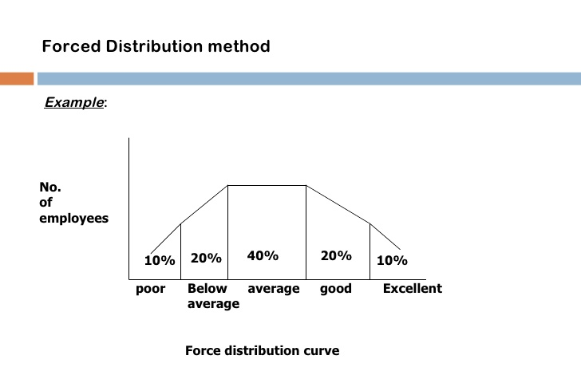
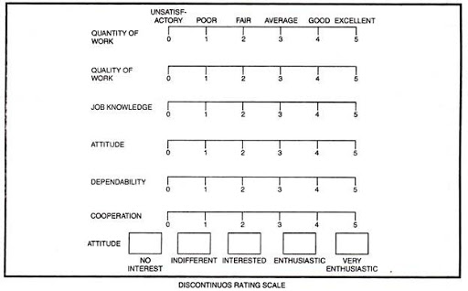

Assume that you have been asked to evaluate the process that caused Anderson’s complaint.
- Describe where the PA system is not S.M.A.R.T.
- Is the PA system vulnerable to rating errors? Which ones? Why? 350 – 450 words

SCENARIO THREE
ABC Early Learning Center is a Day Care Center in Waycross, GA. It has a maximum capacity of 103 children. Harry Smith is the owner of the day care center. He recently had an incident with a 21-year-old teacher, Adam Jones. Adam was an education major at Georgia Southern. He had a 3.5 GPA and experience as a camp counselor. Adam wanted to teach middle school math after graduation. Harry hired Adam to work over the summer. Adam had requested working with children aged 9 – 12, but Harry needed a teacher for the 4 and 5 age group. Adam was disappointed but really needed the job. Adam had studied early childhood development in school and knew how difficult some children could be. For example, he remembered reading that “potentially long-term aggressive behavior can be identified in children as young as age three or four.” His fears were realized within the first week of his employment. Most of his 20 students were great, but four were constantly hitting, throwing things, using profanity, and even biting. Adam was miserable and felt over his head. On June 16, 2019, Adam told Harry that he felt overwhelmed and was worried about the safety of some of the smaller children. Harry responded, “Welcome to the fun world of day care. Be glad that you have a job. If you don’t like it, I hear McDonalds is hiring.” A week later, a parent came to Harry demanding that Adam be fired. The parent said that her five-year-old called Adam a “big scary man.” The mother said she overheard Adam yelling “STOP” at her child for “merely throwing blocks” at another child. To please the mother, Harry fired Adam immediately.

- Looking back, could Harry have handled things differently to avoid having to fire Adam? Would any motivation theories help explain Harry’s failure as a manager?

- Could either discipline perspective have made a difference? Explain. 250 – 350 words

SCENARIO FOUR
Donna Turpin was a plumber for AABC Plumbing until she was fired on November 19, 2019 for insubordination after she complained to the Wage and Hour Division of the Department of Labor about FLSA violations. She had three complaints:
- She often was required to work 12 hours or more without rest or meal breaks. She worked an average of 50 hours per week.
- Beginning in September, she was required to train and supervise the 15-year-old son of AABC’s owner. The 15-year-old “shadowed” Donna every afternoon from 3:00 to 7:30. She found it distracting and felt she was being used as a “babysitter.”
- She was on-call one weekend each month. These were the rules regarding on-call:
  - From 6:00 PM on Friday until 6:00 PM on Sunday, on-call plumbers were required to be at a customer’s home or business within 90 minutes of the call or be terminated. The plumber was paid once he or she arrived at the customer’s home or business.
  - The plumber would receive a text message with instructions to call the dispatcher for information on the emergency.
  - If the employee failed to respond within 15 minutes, the dispatcher sent another text and called.
  - If the plumber failed to respond 30 minutes after the first text, the dispatcher called and sent another text.
  - If the plumber failed to respond to the dispatcher within 5 minutes (35 minutes after the first text), the plumber was terminated.
AABC argued that Donna’s complaints were groundless because she was a supervisor and earned a salary of $4,500 per month.

Do you believe AABC has violated the FLSA? Support your conclusions. 250 – 350 words

